LOW TEMPERATURE COATING BY CVD TECHNOLOGY

J. Gurovič (a), M. Solar (a), F. Černý (a), D. Tischler (a), M. Fajkus (b)

- Faculty of Mechanical Engineering, Czech Technical University in Prague, 166 07 Prague, Czech Republic
- VÚHŽ a.s., Dobrá

Abstract
The contribution deals with the low temperature (below 550°C) deposition of the hard coatings, widely used in the industry. The article describes the technology and the physical and chemical properties of deposited coatings, namely adhesion and chemical composition.

Experimental
The CVD deposition of the wide range of coatings extremely increased in the last 25-30 years. This technology is at present at the same level as e.g. electrolytic coating.
Hard coatings play very important role in the engineering industry and their importance is still increasing. The hard coatings increase the lifetime of various cutting tools and their use has own place especially in the tools family as e.g. rotary drills and hard facet inserts. In such operations hard coatings preserve the tools against the wear and tear and so they extend the tool usable life.
More or less all cutting tools are at present equipped with the surface layer(s) of the hard and abrasion resistant coatings. The coated tools offer two advantages: first they have higher usable life and allow to use the higher cutting speed, second they allow to proceed the machining more precisely and with better quality of the surface.
There are at present basically two methods, CVD and PVD, used for the coating of the cutting and moulding tools. CVD is a chemical formation of the layers from the vapours of the chemical components (Chemical Vapour Deposition), which needs in the conventional conditions relatively high temperatures (1000°C and more). The PVD method is a Physical Vapour Deposition, using some physical processes (as magnetron sputtering) which works at deposition temperatures below ca 500°C.
The CVD coatings bring considerably higher usable time of the coated tools as compared with the PVD coatings, but CVD method (due to volume changes after the deposition) is not suitable for the shape complicated components so as for the details with strong dimension tolerances.
The plasma activated CVD (PACVD) method offer some particular advantages. This method allows to prepare the coatings at the temperatures below 550°C and allows to process the shape complicated components. The speciality is the coating of the inner surface of a small holes and the deposition on the plastics.
Those are the reasons for increased attention to low temperature CVD methods.

TiN and TiCN layers prepared by PACVD method
Major attention in the coating process is concentrated on the choice of most convenient chemical precursors. For treated layers (TiN, TiCN, TiC) appears as the best precursor Tetrakis (DiMethyl (or DiEthyl) Ammonium) Titanium – TDMAT or TDEAT and TiCl₄.
The deposition temperatures are in the case of TDMAT or TDEAT in the range of 100-350°C and the hardness reaches 16 – 21 GPa [1].
The deposition from TiCl₄ proceeds at the temperatures in the range of 450-550°C and the corresponding hardness reaches 23 - 25 GPa [2].
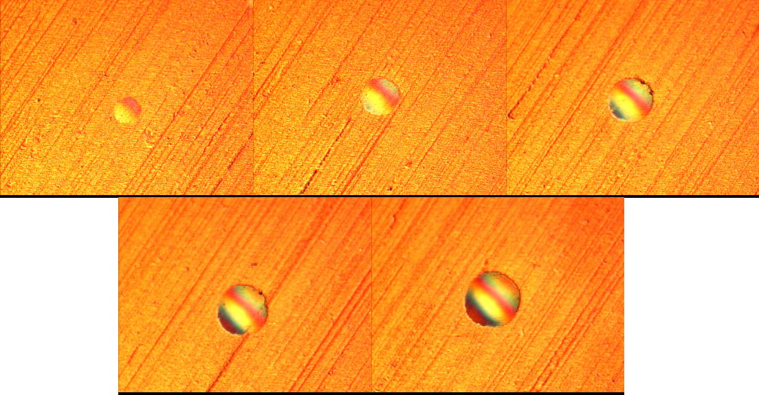

Fig.1: Indentometric prints on TiCN, the loads have been from 30N to 150N, step 30N.

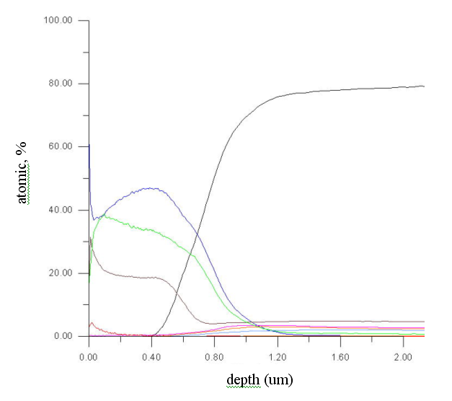
Ti
N
C
Fig.2: Chemical composition of the TiCN layer prepared from TiCl₄

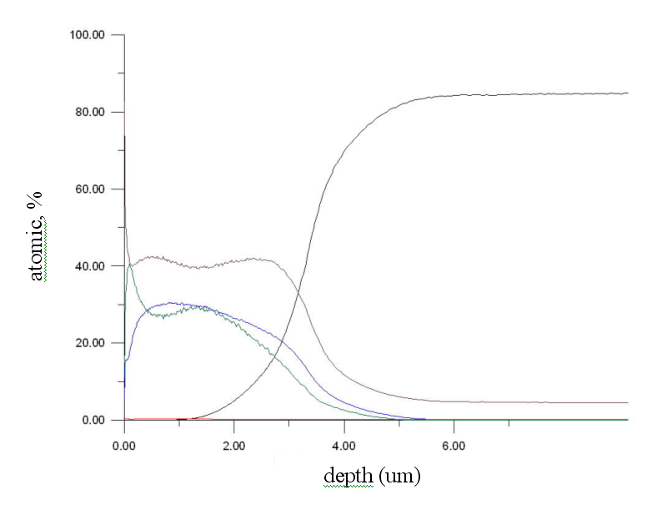
C
Ti
N
Fig.3: Chemical composition of the TiCN layer prepared from TDMAT

Reference
- Comparison of radio frequency and pulsed-d.c. plasma CVD of Ti-C-N-H and Zr-C-N-H layers at low temperature: Wohle J.,Gebauer-Teichman,A.,Rie, K.-T.,Conference: Surf. Coat. Technol.(Switzerand),vol.142-144,Page:661-4 ,July 2001

- Duplex process applied for die-casting and forging tools: Klimek,K.S., Ahn,H., Seebach, I., Wang,M., Rie, K.-T.,Conference: Surf.Coat. Technol. (Switzerland), vol.174-175 , Page: 677-80, Sept.-Oct.2003

